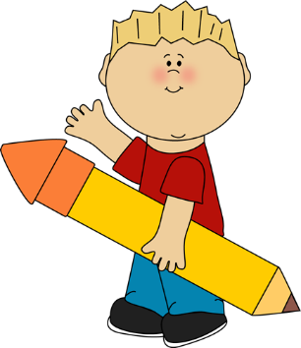
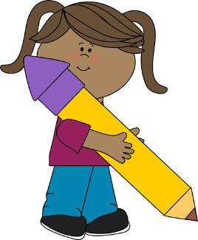
Second Grade
2022-2023
Supply List

- 2 Plastic Duo-Tang folders with pockets and prongs
- 3 composition notebooks
- Pencils (a pack) No. 2 (No mechanical pencils please.)
- Pencil pouch (boxes not allowed)
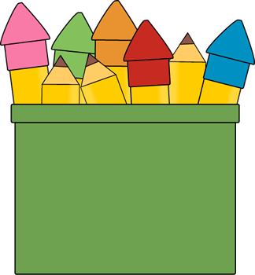
- Eraser caps for pencils and one big pink one
- Red pens
- Pair of scissors
- 24 Crayons (No colored pencils.)
- 3 rolls of Scotch tape in dispenser
- 4 glue sticks
- Black dry erase marker
- One centimeter and inch ruler
- 1 pack of highlighters
- No sharpeners please!
- Dictionary / Thesaurus (may be kept at home)
- 2 reams of copy paper
- Earphones/Buds
- Small white dry erase board (available at dollar store)

Wish List
- 1 ream of color copy paper
- 1 anti-bacterial hand soap (No hand sanitizer please!)
- 2 boxes of tissues
- 1 pack of dry-erase markers
- Lysol or Clorox wipes (No baby wipes please!)

Music
- Red folder with 3 prongs inside

Art
- Composition notebook
- Sketch book

