Zora Neale Hurston Elementary
DECEMBER 2018
Sunday | Monday | Tuesday | Wednesday | Thursday |  | Friday | Saturday
VALUE OF THE MONTH:  FAIRNESS | 3 | 4 | 5  HOLIDAY BOOK GIVEAWAY AT FERGUSON HIGH SCHOOL  5:00-7: 00PM | 6 | 7  PICTURE RETAKES! |  | 8
9 | 10 | 11 | 12  EESAC AT 2:00 PM  HOLIDAY SHOW AND STEM EXHIBIT AT 7:00PM  PARENT ACADEMY  AT 8:30 AM  “UNDERSTANDING MATH” | 13 | 14  PTA JEAN DAY DONATE $1.OO  KONA ICE SALES AFTER SCHOOL  ICE SKATING NIGHT AT KENDALL ICE ARENA AT 6:30 PM |  | 15
16 | 17 | 18 | 19 | 20 | 21 |  | 22
23 | 24  WINTER RECESS BEGINS UNTIL SCHOOL RESUMES ON JANUARY 7^{TH,} 2019 | 25  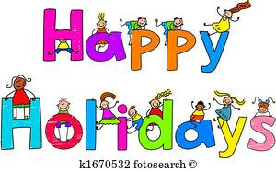 | 26  WINTER RECESS | 27  WINTER RECESS | 28  WINTER RECESS |  | 29  WINTER RECESS
30  WINTER RECESS | 31  WINTER RECESS

