Zora Neale Hurston’s 2018-2019 Summer Reading List
Incoming Kindergarten
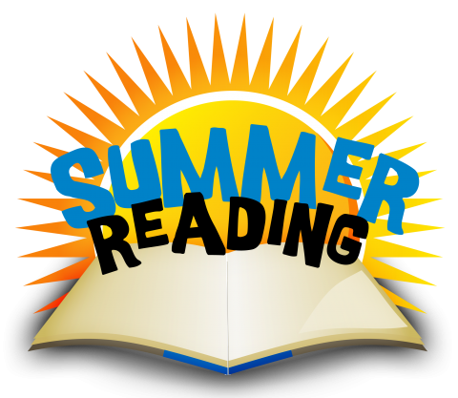
Books
TITLE | AUTHOR | GENRE | AVERAGE PRICE
The Little Red Hen | Byron Barton | Fiction | 13.64
The Very Hungry Caterpillar | Eric Carle | Fiction | 4.99

Activities (choose 1 per book):
- Draw a picture of your favorite page. Explain in writing why this page is your favorite.
- Create a puppet, finger puppet or draw a portrait about your favorite character. Write a sentence or two of what your character would say to the author.

Zora Neale Hurston’s 2018-2019 Summer Reading List
Incoming First Graders

BOOKS AND A SUMMER READING JOURNAL HAVE BEEN PROVIDED TO THE STUDENTS (5/29/18) BY THE READING DEPARTMENT FOR STUDENTS ENTERING FIRST GRADE. TITLES ARE LISTED BELOW.
TITLE | AUTHOR
Around the World with Peppa | Eone
Big Shark, Little Shark | Anna Membrino

Activity for each book
- Summer reading journal given at the school.

Zora Neale Hurston’s 2018-2019 Summer Reading List
Incoming Second Graders
BOOKS AND A SUMMER READING JOURNAL HAVE BEEN PROVIDED TO THE STUDENTS (5/29/18) BY THE READING DEPARTMENT FOR STUDENTS ENTERING SECOND GRADE.

TITLE | AUTHOR
Next Stop Second Grade | Judy Katschke
Lost and Hound | Sydney Malone

Activity for each book
- Summer reading journal given at the school.

Zora Neale Hurston’s 2018-2019 Summer Reading List
Incoming Third Graders
CHOOSE 1 BOOK AND 1 ACTIVITY:
TITLE | AUTHOR | GENRE | Average Price
Separate is Never Equal | Duncan Tonatium | Non-Fiction | 9.50

Activity
- Using a piece of paper, create a collage with words and pictures around the central idea or theme of the book.

TITLE | AUTHOR | GENRE | Average Price
Each Kindness | Jacqueline Woodson | Fiction | 4.76

- Select a character - using a poster to draw a character from the book and explain his/her character traits, motivations, feelings, and actions. Use and cite text evidence.

Zora Neale Hurston’s 2018-2019 Summer Reading List
Incoming Fourth Graders

Book

TITLE | AUTHOR | GENRE | AVERAGE PRICE
Me… Jane | Patrick McDonnell | Non-fiction | 10.70

Activity
- Using multimedia components (graphics, sounds, visual displays) create a poster advertising your books someone else will want to read it.

Zora Neale Hurston’s 2018-2019 Summer Reading List
Incoming Fifth Graders
Please choose 2 books from the following list and complete 1 activity per book.
Books (choose 2):
TITLE | AUTHOR | GENRE | AVERAGE PRICE
Artemis Foul | Eoin Colfer | Fantasy | 7.70
The City of Ember | Jeanne DuPrau | Fantasy | 6.99
Azúcar | Ivar Da Coll | Biography/Multicultural | 11.99
How Tia Lola Came to Visit/Stay | Julia Alvarez | Fiction | 6.99

Activities (choose 1 per book):
- Using multimedia components (graphics, sounds, visual displays) create a poster advertising your books someone else will want to read it.
- Draw a multi-colored movie poster for the book. Put usual movie information on it. (Who would you cast? Location, setting, etc.)

